Education Reform Symposium
Social-Emotional Learning in Ohio Public Elementary Schools

Daniel Rowe, Danny Mylott, & Lucy Beauchamp
CI3010 - Education Controversy and Change
Dr. Sarah Stitzlein
December 7th, 2020

Social-emotional learning (SEL) has had great influence over students' success as long as education and careers have involved understanding others and one's own emotions. The term “social-emotional learning” was developed in 1994 during a meeting between education experts, researchers, and child advocates at the Fetzer Institute. The goal of the meeting was to improve education programming, specifically the issue of including drug prevention, violence prevention, sex education, civic education, and moral education in school curriculum. In the same meeting, The Collaborative for Academic, Social, and Emotional Learning, CASEL, was created. CASEL proposed that SEL can serve as a framework “to align and coordinate school programs and programming.” The group works to continue to accomplish this through their mission: “to help make evidence-based social and emotional learning, SEL, an integral part of education from preschool through high school” (CASEL, 2020).
The Ohio Department of Education defines SEL specifically as, “the process through which children and adults acquire and effectively apply the knowledge, attitudes and skills necessary to understand and manage emotions, set and achieve positive goals, feel and show empathy for others, establish and maintain positive relationships and make responsible decisions” (Ohio Department of Education, 2020). The skills one gains through SEL are as critical for success in kindergarten as they are in someone’s first job. Learning occurs throughout life and SEL is no different. In the same way as academic learning, a good foundation is key in learning effective social-emotional skills. Mastery of SEL skills promotes the highest level of learning in all students, “SEL advances education equity and excellence through authentic school-family-community partnerships to establish learning environments and experiences that feature trusting and collaborative relationships, rigorous and meaningful curriculum and instruction, and ongoing evaluation” (CASEL, 2020). The connection between SEL and community involvement is important in public schools’ prosperity as it builds healthier and safer communities. SEL is “…shown to positively impact economic mobility and mental health outcomes,” (Ohio Department of Education, 2020).
The long-term goal for students in the public-school system is to succeed in the real world. To achieve this, students need good mental health, support structures in their community, and the ability to apply the knowledge they gain in a classroom. Many SEL skills support these needs. In the classroom, SEL is impactful on traditional curriculum as, “The emotional centers of the brain are intricately interwoven with the neocortical areas involved in cognitive learning. When a child trying to learn is caught up in a distressing emotion, the centers for learning are temporarily hampered… there is a direct link between emotions and learning” (Zins et al., 2004). When considering the retention of students in public schools, “SEL is associated with lower rates of risky behaviors, such as drug use and teen pregnancy, and with a decrease in dropout rates of between 5 and 12 percent[9]” (Committee for Children, 2019). SEL is a key predictor of long-term success as well, “Students who have stronger social-emotional skills are more likely to meet educational milestones, such as high school graduation, postsecondary enrollment, and postsecondary completion[5]” (Committee for Children, 2019). Proper SEL supports the whole child throughout their life. A quality education is holistic, considering the needs of the child as a whole, and builds onto itself through diverse experiences beginning at a young age. Although the Ohio Department of Education has begun to integrate SEL into the curriculum, the current system is not structured in a way to ensure all students and families are set up for success.
In 2018 the State Board of Education approved Ohio’s plan called Each Child, Our Future, which they describe as a, “…plan identifies four equally important learning domains that support the academic, personal and social development of PreK-12 students” (Ohio Department of Education, 2019). The four domains are foundational knowledge and skills, well-rounded content, leadership and reasoning, and social-emotional learning. SEL is an obvious point of importance in this policy, yet the implementation is still lacking consistency. A year after Each Child, Our Future was approved, the Ohio State Board of Education adopted SEL standards organized by grade bands. The Department of Education used CASEL’s five “Competencies” as the basis for these standards, as shown in Figure 1. They are, “...five broad and interrelated areas of competence… self-awareness, self-management, social awareness, relationship skills, and responsible decision making” (CASEL, 2020). The concept is that each schools’ teachers will work independently to ensure their students are meeting or actively working towards these standards. Ohio’s Department of Education encourages the integration of SEL into the teaching styles and lessons within teachers’ existing curriculum.
Figure 1
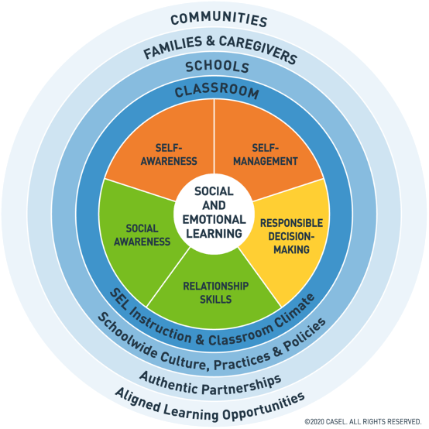
CASEL SEL Framework
Ohio has done well in adding professional development programs that center around SEL. “With the professional development support that will accompany these standards, Ohio is providing guidance for implementing the standards into instruction, so all teachers can reap the benefits of supporting students’ social-emotional learning development” (Ohio Department of Education, 2019). Yet the current standards could still be considered nothing more than suggestions. The Ohio Department of Education states: “Each district and school will decide for itself the extent to which it uses these standards and how to use these standards” (Ohio Department of Education, 2020). This leaves quite a bit of room for error throughout Ohio’s 3,583 public schools, which could have large consequences when it comes to students’ overall learning. Literacy falls under the foundational knowledge and skills domain and must be proven by 3rd grade, when large-scale standardized testing begins. Early SEL screening should be considered similarly foundational to ensure healthy social and emotional development.
Some of the most important skills that students need after high school regardless of occupation are social-emotional: self-awareness, relationship skills, self-management, and social awareness. But they are currently informal learning in most schools’ curriculums. Teachers may or may not emphasize these skills through their general instruction, and if students do not have a teacher who chooses to focus on them, they are left to learn from the media, their home, and their community. This creates huge variation in what “soft skills” students have when they graduate high school, middle school, elementary school, and even kindergarten. Numerous studies have demonstrated a strong relationship between kindergarten readiness and later development. Kindergartners who were identified as not behaviorally ready had much higher likelihoods of being retained in grade, receiving services through an IEP or 504 plan, and being suspended or expelled (Bettencourt et al., 2017). It is clear that to improve the skills of graduates, one must first develop a strong foundation for the youngest students. To improve academic achievement and promote behavioral development, we propose instituting periodic SEL screenings through formative assessments in early elementary schools and publishing these findings in addition to school-reported SEL support structures on Ohio Elementary School Report Cards.
These recommendations could be accomplished through an amendment to an existing bill in the Ohio Statehouse. This would be significantly easier to implement than introducing a new bill and appeals to legislators as it is a familiar method of action while being more feasible. The impact of the proposal would be to improve students’ social-emotional skills through increased school focus and distribution of funding. Like academic achievement, SEL is important, however it cannot wholly overcome the lack of resources some schools face especially when they serve poor urban and rural students. The early SEL screenings will not be published as A-F grades; they are meant to inform instruction and can serve as an indicator that a school needs additional funding or resources to provide the additional support that its students need. The screenings are performed twice per year to evaluate student growth and enable teachers to identify what instructional practices are working.
It is imperative that screening occur as early as possible to establish a base for students’ social-emotional learning. This opens the door for analysis of when students are learning SEL skills, which practices work best for developing them, and how student growth is affected by instruction and screening. We propose for screening to be performed once at the beginning of the year and once at the end of the year for kindergarten through second grade. Schools will choose at least one screening; we suggest the Devereux Student Strengths Assessment, the Six Seconds Perspective Youth Assessment, or the SSIS SEL Edition Screening and Progress Monitoring Scales, but the school should choose the assessment that fits their situation best. These are intended to formative assessments – they should inform instruction. The results of the assessments provide information for teachers to reference and use to improve how they teach and support SEL in their classrooms. The screenings are biannual and should be completed within one month of the first day of school and one month before the last day of school for all students. This is to identify students’ competencies at the beginning and end of the year to be able to analyze a school’s impact on students’ SEL skills.
There are already a formidable number of tests that many teachers must administer, but these SEL screenings will not add to this over-testing because they are designed for currently untested grade levels, quick to perform, and require little preparation. State testing begins in the third grade, which is not included in the recommendation for grades that should implement SEL screenings (Ohio’s, 2020). The recommended screenings take 15 minutes or less and can be given to many students simultaneously. Importantly, these are not tests that require weeks of preparation that take away from valuable classroom instruction. Since the screenings are designed for young children, only a short introduction to the test may be necessary for students to be able to properly complete it. Teachers and administrators do not have to worry about cutting vital instruction time to measure the social-emotional learning in their school. The recommended screenings were chosen because they are short, simple, can be integrated into an instructional model, and are backed by experts. Craig Dobson, a behavioral health therapist at Beech Acres Parenting Center, asserted that “anytime you can make simple to understand and quick assessment, I think it’s a positive.” Robert Kelly, director of the Center for Social-Emotional Learning, contends not only that, “assessments should be an integral part of an SEL program,” but also that “school-based assessments for K-2… should be adopted as part of an integrated model.”
The students are not the only ones being assessed, however. It is important that scores from the SEL screenings not be the only measure of a school’s SEL approach and success. We recognize that some schools would have a distinct advantage if this were the case as already occurs in other areas of the Ohio School Report Card. The resources and programs that a school has that foster SEL are important to consider. This would be achieved through a questionnaire sent to school administrators who would answer questions about their school’s resources and approach, see Figure 2 for a sample with answers from a teacher at the School for the Creative and Performing Arts, a CPS school. It reinforces local control by individualizing each school, with each one able to highlight their values and showcase their unique or exciting offerings.
Figure 2
Sample Resource Evaluation
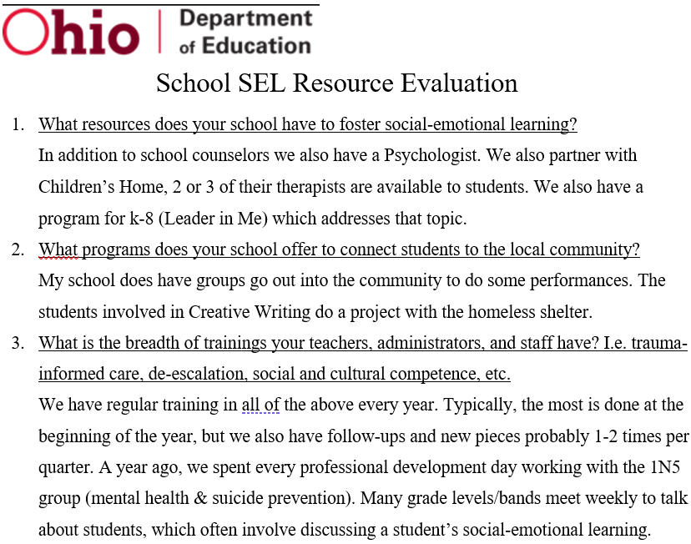
While SEL is becoming a hot topic in education, it has not yet received adequate funding to allow schools to actually address their shortcomings in this area. Adding measures of SEL to the Ohio School Report Card would spotlight the issue and incentivize legislators to apportion funding for SEL. It would also provide a holistic education report for parents as they choose where to send their children for the formative grade levels of K-2. Every child is different and deserves a school that is geared towards their needs. Imagine a parent who, instead of just seeing the current Ohio School Report Card that has letter grades with no description, could refer to an evaluation as shown previously in Figure 2 that details how a school approaches social awareness, behavioral development, and more. This is a more holistic version that gives parents more data so they can make an informed choice on where to send their child for early elementary. There are concerns about fairness of the growth section and overall Ohio School Report Card that this qualitative element and inclusion of SEL growth could address. The qualitative portion allows schools that have high achievement and schools which serve high-need populations to provide context to their learning environments and student population.
Schools must be held accountable for their progress toward and commitment to Ohio SEL standards, but they should also be recognized for their successful programs. The Ohio Department of Education already gives awards for schools that close achievement gaps, sustain high achievement, and show significant all-around progress. An awards section should be added that recognizes top schools for their approach to SEL. The basis for receiving a proposed Award for Developmental Excellence could be innovative approaches to SEL, use of community resources and partnerships, or variety of behavioral development teacher training. The final criteria should be determined by the Ohio Department of Education such that schools that serve all types of students are eligible for recognition, not only schools that have significant resources and are in high-wealth districts. This recognition will showcase schools that are committed to SEL to provide an example for other Ohio schools as well as reward the schools through increased recognition. This will also be a showcase for the state as its schools are distinguished in a way that has not been done in any other state.
Based on our research, we believe that our proposal will help increase the implementation and effectiveness of SEL in Ohio schools. SEL has already proven to have several substantial positive outcomes for our students and on our economy. SEL increases student growth and has a high return on investment. In addition, our proposed early SEL screening would help schools address early learning gaps, which is a key tenet of academic equity. SEL increases student growth and cognitive development. Over the past few decades, researchers have conducted hundreds of studies on whether or not SEL really increased student outcomes. Figure 3 showcases practical benefits of the institution of an SEL program..
Figure 3
The Practical Benefits of an SEL Program
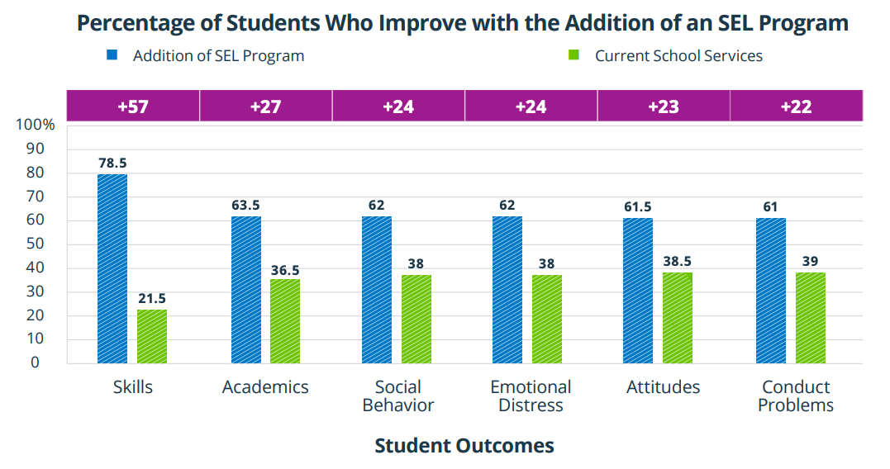
CASEL found that implementing SEL in schools has several large value-added benefits for students. If a school implements SEL programs, 27% more students improve academic performance, 57% more gain in their skills levels, 24% more improve social behaviors and lower levels of distress, 23% more have improved attitudes, and 22% more would show fewer conduct problems (Durlak & Mahoney, 2019). According to a 2011 meta-analysis of 213 school-based SEL programs involving over 270,000 students K-12, “SEL participants demonstrated significantly improved social and emotional skills, attitudes, behavior, and academic performance that reflected an 11-percentile-point gain in achievement” (Durlak et al., 2011). In addition to having this substantial achievement gain, SEL has been shown to have long lasting effects on students. Six years after conducting their 2011 meta-analysis of added student achievement, some of the same researchers conducted another meta-analysis to see just how long these effects lasted. They found that the benefits of SEL implementation have lasted up to 18 years, and SEL participants were 6% more likely to graduate high school and 11% more likely to graduate college than their peers (Taylor et. al, 2017). Not only does SEL benefit student growth both in the short and long-run, but it also appeals to policymakers across the political spectrum.
SEL implementation goes hand in hand with educational equity, a key tenet of Democratic educational policy. A bipartisan report from American Enterprise Institute and Brookings Institution identified four recommendations to help reduce the growing education gap in America. One of these key recommendations was to educate the whole child through SEL programs (AEI/Brookings, 2015). They found that at only 9 months old, infants from low-income families scored lower than infants from high-income families in cognitive and social-emotional development (AEI/Brookings, 2015). By the age of 24 months, this gap had doubled (AEI/Brookings, 2015). Therefore, children from disadvantaged backgrounds are already behind their peers before they enter a classroom. Our proposed early SEL screening would help teachers identify and address these gaps in social-emotional development allowing our education system to be more equitable. In addition, SEL programs have long had the goal of promoting academic equity, diversity, and inclusion. CASEL’s board chair and board vice-chair, Timothy P. Shriver and Roger P. Weissberg (2020), recently spoke of this dedication: “CASEL has always recommended programs designed to help students and teachers build strong, respectful relationships founded on an appreciation of similarities and differences; critically examine root causes of inequity, and develop collaborative solutions that address community and social problems”. Our SEL proposal appeals to liberal legislators in these respects, but also has a great case for conservative legislators.
SEL has proven to be an excellent educational investment and promotes academic excellence, key tenets of Republican educational policy. In 2015, the Center for Benefit-Cost Studies in Education at Columbia University studied SEL’s return on investment in six large scale SEL interventions and found that these programs had an 11 to 1 return on investment when accounting for lifetime earnings, mental and physical health, and juvenile crime (Belfield et al, 2015). In addition, the Bennett Pierce Prevention Research Center at Pennsylvania State University studied the long-term effects of investing in SEL in early childhood education in other cost-effective criteria. They found that, “SEL decreased the likelihood of living in or being on a waiting list for public housing, receiving public assistance, having any involvement with police before adulthood, and ever spending time in a detention facility” (Jones et al., 2015). SEL’s return on investment may be even higher than 11 to 1 when accounting for how it decreases the use of public housing and public assistance, thus further saving taxpayer money. Our proposal focuses on early intervention which is concurrent with these two studies. Also, we propose that Ohio recognizes schools who implement SEL exceptionally well. This is an opportunity for Ohio to showcase academic excellence in the state and set itself as a leader in the nation.
If Ohio chooses to adopt our proposal, they would be implementing SEL practices supported by states that are educational leaders in America. The state of Massachusetts is widely regarded for its public elementary and secondary schools. Similar to Ohio, the Massachusetts Department of Elementary and Secondary Education has designated SEL as one of their five strategic priorities (Massachusetts Department of Elementary and Secondary Education, 2019). But Massachusetts has taken a step further and required SEL screening in kindergarten, a key part of our proposal. If Ohio adopts our proposal, they would surpass Massachusetts' SEL screening standards through formative SEL assessments beyond kindergarten. We want to note that required SEL screening brings up the only part of our proposal that we believe could have legal implications. If an Ohio elementary school chooses not to conduct the required SEL screenings, this could lead to legal troubles between parents, the school, and the Ohio Department of Education. This is the only anticipated legal implication of our proposal, and it seems unlikely.
Ohio teachers, union members, and community leaders in SEL have shown overwhelming support of our proposal and provided us with essential constructive feedback to improve our plan. We conducted interviews with 13 teachers, school administrators, and local educational experts concerning our proposal. Every person agreed that SEL should be a priority in education. Amy Graff, who has been teaching preschool in Cincinnati Public Schools for 35 years, stated that, “if you are a concerned and loving teacher, SEL is a very integral part of your day.” We also received support from these individuals for implementing SEL screenings in early education. Several teachers urged us to ensure that these SEL screenings would be used for student growth and action, not just used as a test score. Dr. Danny Newman, an Associate Professor in UC’s school psychology program and active member of the Mental Health Collaborative between UC and the Arlitt preschool, stressed the importance of how SEL assessments should be used to help guide instruction: “The focus of the assessment should not just be to assess and get a score, but to guide instructional practices and to measure students’ responsiveness to instruction and to determine if a student or students need something more instructionally.” We have incorporated this feedback in our proposal to appropriately stress the purpose of these SEL screenings. These educators and educational leaders also helped us identify significant blockers that could hinder our proposal.
The key obstacles hindering our SEL proposal are assessments taking time from instruction, the difficulty in quantifying SEL growth for the Ohio School Report Card, and a lack of teacher training. One of the main concerns of our educational system today is the overuse of standardized testing. Adding yet another mandated assessment to the mix is likely to not be received well if done the wrong way. Megan Kreaps, who has been teaching ESL in urban schools for seven years, urged us to think critically of how to make sure SEL screenings would not take away valuable instruction time from the classroom. This is the norm for many screenings, including options shared through CASEL’s website that take fifteen minutes or less mentioned earlier that will be suggested to the legislators. Abigail Roos, a second-year preschool teacher in Cincinnati, also recommended that to make these screenings more integrated into class instruction, teacher observation during classwork could be used as the main source of SEL screening. Secondly, SEL growth is inherently more difficult to quantify than other subjects like math. Abigail Rood expressed concern with including SEL growth on the Ohio School Report Card due to this difficulty, which was a driver of the inclusion of the scores within the qualitative section of our proposal for the Ohio School Report Card. Finally, Dr. Victoria Carr, the Associate Professor of early childhood education at UC and director of the Arlitt Child and Family Research and Education Center, expressed the need for more SEL focused teacher trainings. She stated that currently, “teachers lack the trauma-informed care knowledge, skill set, tools, and resources to address the growing impacts [of trauma] on children.” We agree that this is concerning and should be addressed to better serve our students, but we determined that it would be too broad-sweeping and overwhelming for legislators to address teacher training in our proposal as well. (Perhaps a group in the next cohort might want to address the need of trauma-informed care training for teachers!)
There are existing community organizations and nonprofits throughout Ohio that support SEL for students. We were able to connect with representatives from two local SEL organizations: Beech Acres Parenting Center and the Center for Social-Emotional Learning. Beech Acres works to empower local parents in several ways, including through promoting SEL. The Center for Social-Emotional Learning directs SEL programs in Cincinnati. From speaking with Craig Dobson of Beech Acres and Robert Kelly of the Center for Social-Emotional Learning, the consensus is clear: SEL works and should be further supported in our schools. Both individuals supported early SEL screening and its inclusion in the Ohio School Report Card as outlined in our proposal. This support from teachers, administrators, union members, experts, and local organizations gives us faith that our proposal is sound and can have a real, positive impact on Ohio students.
If executed, SEL prioritization in Ohio public schools will have significant impacts. The teacher training programs already in place would be able to focus on specific areas of challenge for each school. These programs may also be expanded as SEL is prioritized by including them in a new teachers’ preparation or, more specifically, providing Trauma-Informed Care Training. There are numerous trainings for education professionals already developed and available through CASEL’s resources. The resources exist; they just need to be implemented. With the accountability created with public disclosure of SEL on School Report Cards we also believe support staff in public schools will gain importance. Counselors, therapists, and social workers are essential components to maintaining students’ health and safety, which in turn makes learning possible. Social-emotional intelligence and sensitivity amongst students and faculty will lead to more effective educating of all students, no matter their background. There will no longer be a need to simply assume SEL is happening in the home when that is not always the case. While we acknowledge that early SEL screening and the additional support structures that may come about in effect are not free, all students deserve this solid foundation in life and in school.
The Every Student Succeeds Act includes funding mechanisms to support SEL in schools. The Wallace Foundation explains that the ESSA does not specifically mention SEL in any way, but there are two possible funding methods within the policy. The first is Title II: Preparing, Training, and Recruiting High-Quality Teachers, Principals, or Other School Leaders which, “...authorizes funding to support the preparation, training, and recruitment of educators at all levels of the school system” (RAND, 2017). There is also the possibility of also applying for the Supporting Effective Educator Development and School Leader Recruitment and Support grants to help reinforce the funding of SEL professional development programs. Additionally, Title IV: 21st Century Schools of the ESSA sanctions funding for a variety of programs that improve students’ educational opportunities, “These may be sought in three subareas: (1) Part A: Student Support and Academic Enrichment Grants, (2) Part B: 21st -Century Community Learning Centers, and (3) Part F: National Activities” (RAND, 2017). The ESSA overall requires “evidence-based intervention” and many SEL intervention programs already meet these evidence requirements. There is a funding structure already in place that would support institution of high-quality social and emotional learning in Ohio’s public schools.
Social and emotional learning is an integral part of a good education. Ohio public schools intend to set all students up for success and, “...that our children are supported to be lifelong learners who develop into adults who make significant contributions to the world” (Ohio Department of Education, 2020). SEL is proven to increase the rate students earn high school and college degrees (Committee for Children, 2019), support skills needed for success in careers (Ohio Department of Education, 2020), and overall improve mental health (Committee for Children, 2019). We propose the addition of early SEL screening through formative assessments and school-reported SEL support structures and making them public knowledge through the Ohio Elementary School Report Cards. These changes may not seem monumental because no new bills need to be passed nor does the Ohio Department of Education’s budget need to be redesigned, but it will set children up for education, professional, and personal success which is undoubtedly monumental. Learning, including SEL, not only changes a student’s life, but uplifts communities. When schools prioritize social and emotional skills, they, support the health and safety and equality of all students within education.

“Our goal should remain simple and strong: to educate both head and heart
in ways that optimize the achievement and positive development of every child.”
- Timothy P. Shriver and Roger P. Weissberg
Works Cited
AEI/Brookings Working Group on Poverty and Opportunity. (2015). Opportunity, Responsibility, and Security: A consensus plan for reducing poverty and restoring the American dream. https://www.brookings.edu/wp-content/uploads/2016/07/Full-Report.pdf
Belfield, C., Bowden, B., Klapp, A., Levin, H., Shand, R., & Zander, S. (2015, February). The Economic Value of Social and Emotional Learning. Center for Benefit-Cost Studies in Education: Teachers College, Columbia University. http://blogs.edweek.org/edweek/rulesforengagement/SEL-Revised.pdf
Bettencourt, Amie F., Gross, Deborah, Ho, Grace, & Perrin, Nancy. (2017). The costly consequences of not being socially and behaviorally ready to learn by kindergarten in Baltimore city. Journal of Urban Health, 95(1), 36-50. https://dx.doi.org/10.1007%2Fs11524-017-0214-6
CASEL. (2020). About CASEL. CASEL. https://casel.org/about-2/
CASEL. (2020). SEL is... CASEL. https://casel.org/what-is-sel/
Committee For Children. (2019). What Is Social-Emotional Learning? Committee For Children. https://www.cfchildren.org/wp-content/uploads/policy-advocacy/what-and-why-one-pager.pdf
Durlak, J. A., Mahoney, J. L. (2019, December). The Practical Benefits of an SEL Program. Collaborative for Academic, Social, and Emotional Learning (CASEL). https://casel.org/wp-content/uploads/2019/12/Practical-Benefits-of-SEL-Program.pdf
Durlak, J. A., Weissberg, R. P., Dymnicki, A. B., Taylor, R. D. & Schellinger, K. B. (2011). The impact of enhancing students’ social and emotional learning: A meta-analysis of school-based universal interventions. Child Development, 82(1), 405–432. https://doi.org/10.1111/j.1467-8624.2010.01564.x
Early Social-Emotional Functioning and Public Health: The Relationship Between Kindergarten Social Competence and Future Wellness. American Journal of Public Health 105(11), 2283-2290. https://doi.org/10.2105/AJPH.2015.302630
Jones, D. E., Greenberg, M., & Crowley, M., (2015, February 10).
Massachusetts Department of Elementary and Secondary Education. (2019, February). Strategic Plan. http://www.doe.mass.edu/research/strategicplan.docx
Ohio's K-12 Social and Emotional Learning Standards. Ohio Department of Education. (2019, June). http://education.ohio.gov/getattachment/Topics/Learning-in-Ohio/Social-and-Emotional- Learning/Social-and-Emotional-Learning-Standards/K-12-SEL-Standards-Full-Final.pdf.aspx?lang=en-US
Ohio's State Tests in English Language Arts, Mathematics, Science and Social Studies. (2020). Retrieved December 06, 2020. http://education.ohio.gov/Topics/Testing/Ohios-State-Test-in-ELA-Math-Science-SocialStudies
RAND. (2017). How The Every Student Succeeds Act Can Support Social and Emotional Learning. Wallace Foundation. http://education.ohio.gov/getattachment/Topics/Learning-in-Ohio/Social-and-Emotional-Learning/Social-and-Emotional-Learning- Standards/K-12-SEL-Standards-Full-Final.pdf.aspx?lang=en-US
Shriver, T. & Weissberg, R. (2020). A response to constructive criticism of Social and Emotional Learning. Phi Delta Kappan, 101(7), 52-57. https://doi.org/10.1177/0031721720917543
Social and Emotional Learning. Ohio Department of Education. (2020). http://education.ohio.gov/Topics/Learning-in-Ohio/Social-and-Emotional-Learning
Taylor, R. D., Oberle, E., Durlack, J. A., & Weissberg, R. P. (2017). Promoting Positive Youth Development Through School‐Based Social and Emotional Learning Interventions: A Meta‐Analysis of Follow‐Up Effects. Child Development, 88(4), 1156-1171. https://doi.org/10.1111/cdev.12864
Zins, J. E. (2004). Building academic success on social and emotional learning: what does the research say? Google Books. Teachers College Press. https://books.google.com/books?id=MuDGDHCb_iwC&printsec=copyright#v=onepage&q&f=false

